C O M M O N S H I R E S
Thriving States of Being that have Resolved Coping States of Struggle

TERRAQUISTA COMMONSHIRE
The Cooperation and Co-Creation(leaderless), Living Stewardship (jobless),
and Communal Asset (moneyless) Commonwealth of the NA25 Bioregion

Commonshires are populations organizing to live cohesively and adaptively across differences with all life in Universal Thriving Wellness and Well-being or UTW. Ten Sights Institutes of Social Cohesion (TSiSC) assists populations in becoming commonshires by re-formulating living patterns and systems of functioning that generate disparity and discord, of any kind, to instead demonstrate the cooperative interdependence of bioregional ecosystems and other models of integral living.
Through the Chevil Até Project, TSiSC is mapping these reformulations to interlink them as an interdependent network. Chevil Até’s current emphasis is on its ChAPter Three (C3) mapping of the four ecoregions of the Southeast Savannas and Riparian Forests bioregion of North America (NA25)…where the Terraquista Commonshire is joining Cascadia (NA16 Bioregion), Shasta (NA31 Bioregion) and others in reformulating their patterns of living to ecosystemically cooperate with all life rather than geopolitically compete with any.
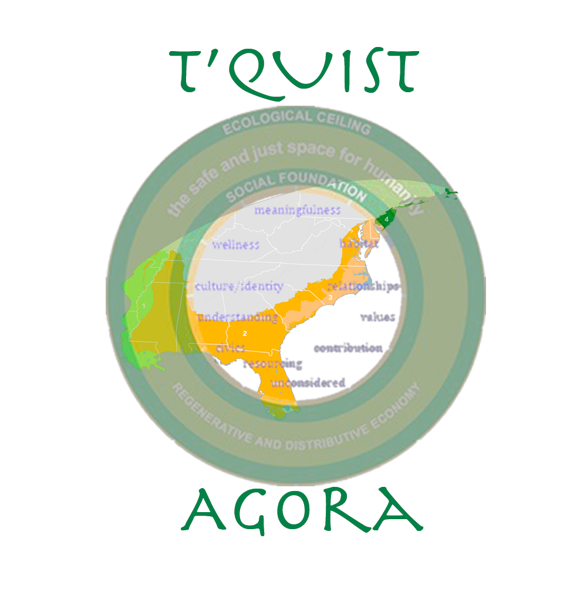
Terraquista is incubating the Terraquista Common Collective as a league of enterprises operating in UTW formulations of cooperation and co-creation that enables every cohesively distinguishing way of functioning in life, living stewardship for contributing to life in the archetypal distinctions of every soul’s nature and spirit, and communal asset resourcing in which living necessities are collectively maintained and regeneratively distributed throughout the population. Terraquista’s other initial undertaking is the T’Quist Agora as forums for expanding the Terraquista population’s consensus on its commonshire configurations.

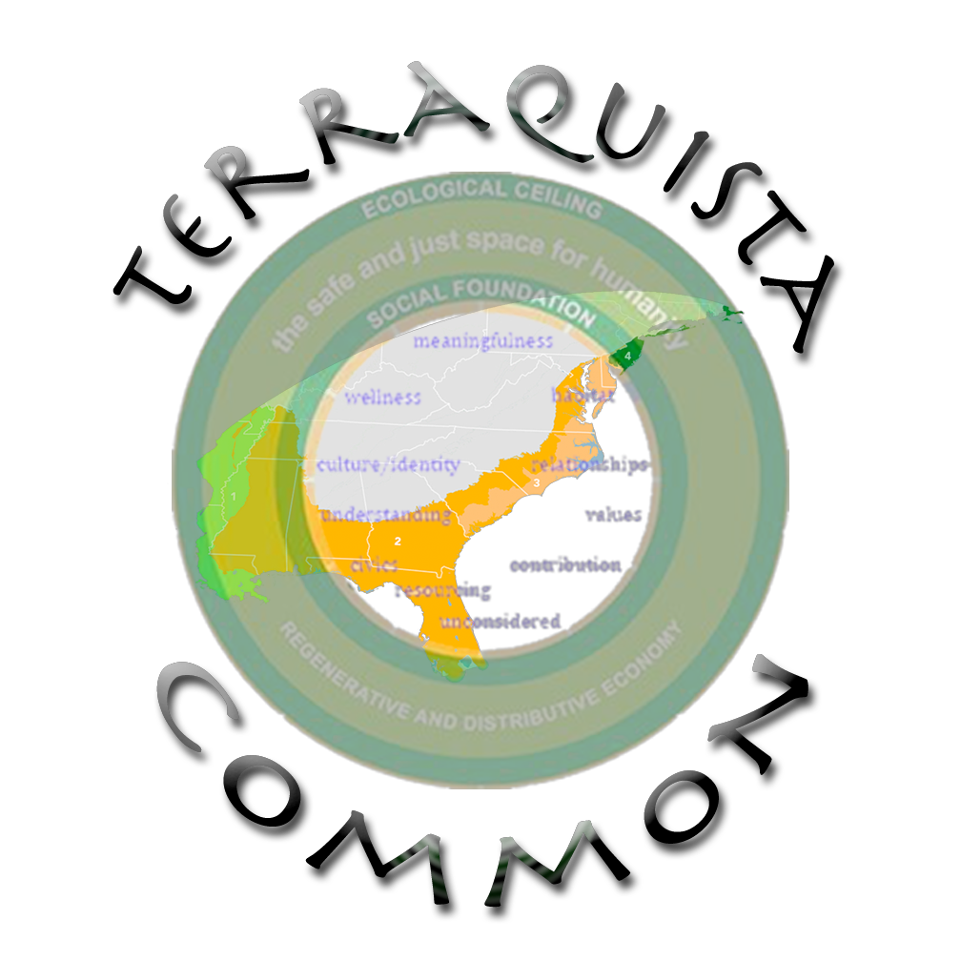

A collective for re-imagining enterprise to preserve and defend the common interest and living systems of all life throughout the NA25 bioregion
The Chevil Até Project’ s ChAPter Three mapping of UTW formulated living patterns and systems of functioning for the NA25 Bioregion
Forums for reclaiming the Terraquista population’s ability, at the community level, to collectively steward essential living needs as social entitlements instead of commercial markets

Ten Sights Institutes of Social Cohesion * Abundance League 3 of the Chevil Até Project’s ChAPter Three mapping of the NA25 Bioregion
P.O. Box 870212 Ecoregion 399 Bvlbancha (New Orleans, LA) 70187, NA25 Bioregion, Terraquista Commonshire
(504) 301-9222 * tsisc@swansreach.org * www.swansreach.org/tsisc * www.swansreach.org/terraquista

TERRAQUISTA CON CEPTUALIZATION S
By tapping into the genius of distinguishing spirit and soulful cravings that are unique to each of us–and as the only champions of these passions there will ever be in life–let us all imagine how to thrivingly coexist with others in integral and interdependent partnership.
In the living endeavor categories below, how are you awakening to the longings of your soul…able to visualize living in common thriving and cooperation with all life…or would resolve living struggles that the NA25region has with systemic imbalance and injustice.

TE N SI G H TS C A TE G O R I E S O F L I V I N G E N D E A V O R
1@ | CONTEXTS OF MEANINGFULNESS [Perspective Worldview]
2@ | WELLNESS [Health; Healing; Safety; and Security]
3@ | ENVIRONMENT and HABITAT
4@ | CULTURE and IDENTITY
5@ | RELATIONSHIPS
6@ | UNDERSTANDING [Learning & Education; Exploration & Discovery; and Communications & Media]
7@ | PRINCIPLE VALUES [Ethics; Philosophy; Spirituality; Religion; and Mysticism]
8@ | CIVICS; GOVERNANCE; and LAW
9@ | LIFE PRACTICE and RESOURCING [Ritualized Intention; Economics and Other Resourcing Systems]
10@ | SCIENCE and TECHNOLOGY
0@ | PREVIOUSLY UNCONSIDERED
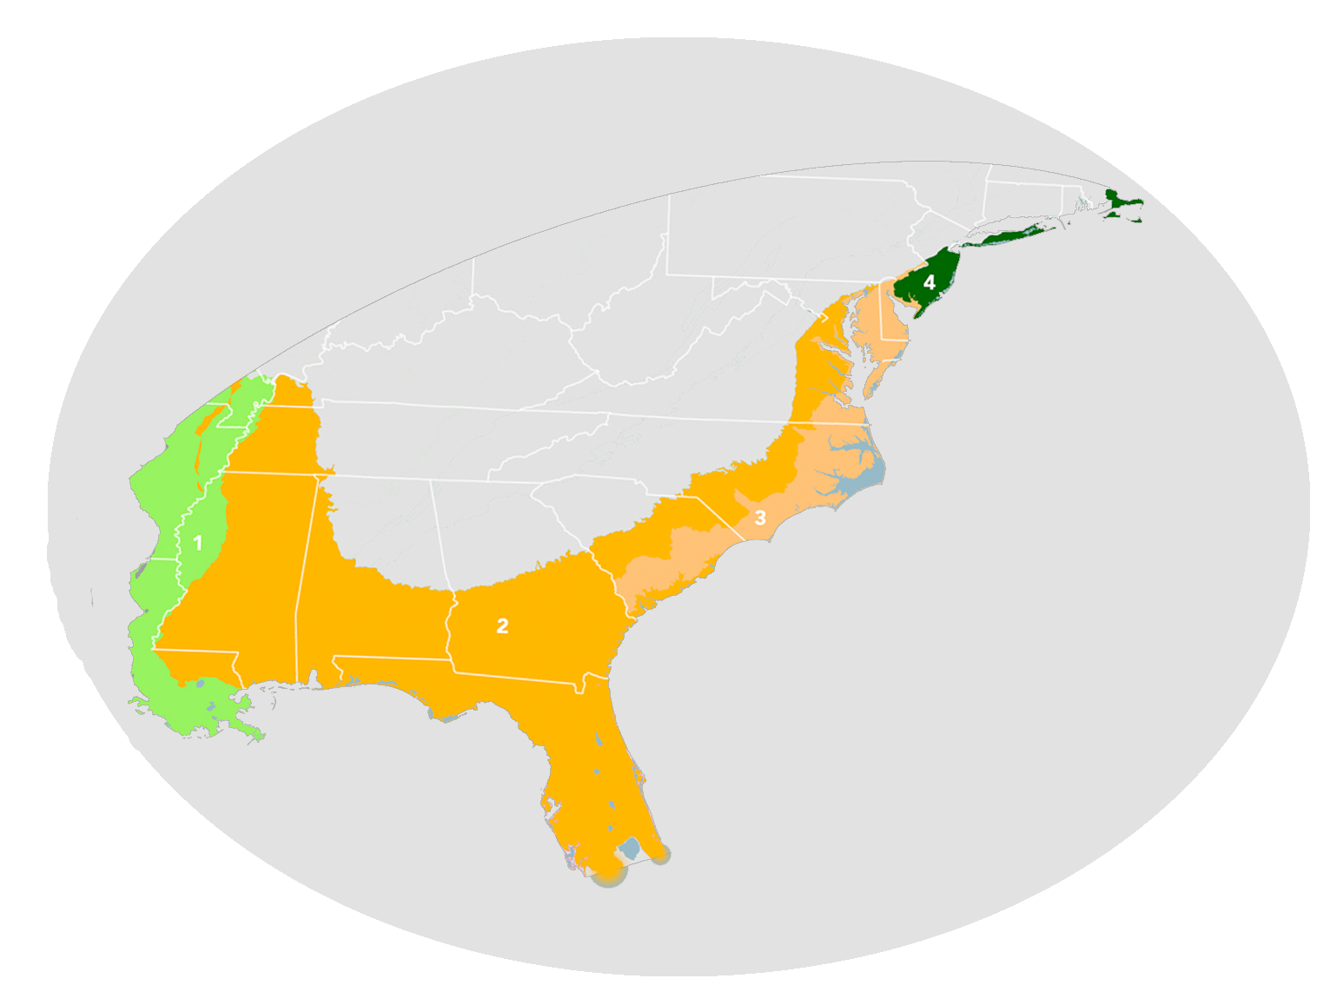
Terraquista Commonshire
The Southeast Savannas and Riparian Forests bioregion of North America (NA25)

